Day 1   
Employee ID:109134424   
Login ID:rngro   
Name:-Ranga Narayana Srinivas Rao  
  
1)What is SDLC?  
Answer:-SDLC stands for Software Development Life Cycle. It is a structured process used for developing high-quality software systematically and efficiently. It outlines the steps involved in the development of software from initial planning to deployment and maintenance.   
  
2)Why is SDLC?   
Answer:-

1. It provides a clear structure for software development, helping teams follow a step-by-step process.
2. It improves product quality by ensuring each phase (like testing and review) catches issues early.
3. It reduces development risks through proper planning, analysis, and design before coding begins.
4. It ensures software meets user requirements by involving stakeholders in requirement gathering and validation.
5. It helps manage time and cost efficiently by setting clear timelines, budgets, and responsibilities.

3)What are the stages of SDLC?   
Answer:-

1. Requirement Gathering and Analysis
2. Planning
3. Design
4. Development
5. Testing
6. Deployment
7. Maintenance

4)what are SDLC models?  
Answer:-

1. **Waterfall Model**  
   In the Waterfall model, each phase is completed before moving to the next one.  
   It follows a linear and step-by-step approach.  
   Once a phase is finished, you cannot go back to it.  
   It is simple to understand but not flexible for changes.
2. **V-Model**  
   The V-Model is an extension of the Waterfall model.  
   It emphasizes testing at every development stage.  
   Each development phase has a corresponding testing phase.  
   It is useful when requirements are clear and stable.
3. **Iterative Model**  
   The Iterative model builds the software in small parts or versions.  
   Each version is improved based on feedback from the previous one.  
   It allows changes and improvements during development.  
   It is helpful when requirements are not fully clear at the start.
4. **Spiral Model**  
   The Spiral model combines design and prototyping in stages.  
   It focuses on risk analysis and handles large, complex projects.  
   Each loop in the spiral represents a phase in the process.  
   It is flexible but can be expensive and complex to manage.
5. **Big Bang Model**  
   The Big Bang model starts with little or no planning.  
   Developers begin coding with the idea that things will be figured out later.  
   It is suitable for small projects or experiments.  
   It can be risky for larger projects due to lack of structure.
6. **Agile Model**  
   The Agile model delivers software in small, working pieces called iterations.  
   Teams work closely with users and adapt to changes quickly.  
   It encourages collaboration, feedback, and fast delivery.  
   It is ideal for dynamic projects with changing requirements.
7. **DevOps Model**  
   DevOps combines software development and IT operations.  
   It focuses on continuous integration, testing, and deployment.  
   Teams work together to deliver faster and more reliable updates.  
   Automation tools are used to speed up and improve the process.

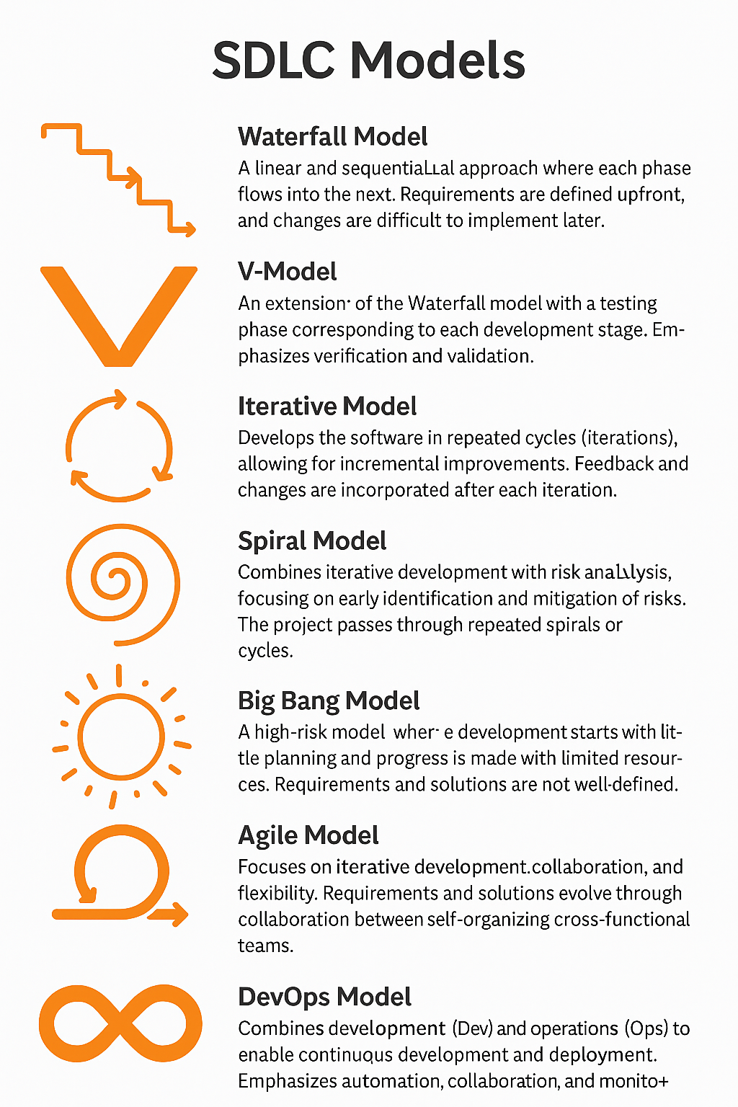  
  
5)What are different Network types?   
Answer:-

1. Personal Area Network (PAN)
2. Local Area Network (LAN)
3. Metropolitan Area Network (MAN)
4. Wide Area Network (WAN)
5. Wireless Local Area Network (WLAN)
6. Campus Area Network (CAN)
7. Virtual Private Network (VPN)

6)What are the types of servers?  
Answer:-

1. **Web Server**  
   A web server hosts websites and serves web pages to clients via the internet. It handles requests from browsers and returns content like HTML files, images, and scripts.
   * Example: Apache HTTP Server, Nginx.
2. **Database Server**  
   A database server stores and manages databases, processing queries and ensuring data integrity. It allows applications to access and modify data stored in a structured manner.
   * Example: MySQL, Oracle Database.
3. **File Server**  
   A file server is used to store and manage files within a network. It allows users to access, store, and share files securely over the network.
   * Example: Windows Server, Network-Attached Storage (NAS).
4. **Mail Server**  
   A mail server handles the sending, receiving, and storage of emails. It uses email protocols like SMTP, IMAP, and POP3 to process email communication.
   * Example: Microsoft Exchange, Postfix.
5. **Application Server**  
   An application server provides an environment for running applications, including hosting the business logic and enabling communication between databases and clients.
   * Example: Apache Tomcat, IBM WebSphere.
6. **FTP Server**  
   An FTP (File Transfer Protocol) server enables file transfers over a network. It supports uploading and downloading files using FTP protocols, often used for large data exchanges.
   * Example: FileZilla Server, Core FTP.
7. **Proxy Server**  
   A proxy server acts as an intermediary between clients and other servers. It is often used to filter requests, cache content, or hide the client's identity for privacy and security.
   * Example: Squid Proxy, Nginx (reverse proxy).
8. **DNS Server**  
   A DNS (Domain Name System) server resolves domain names to IP addresses, allowing users to access websites by their human-readable names rather than IP addresses.
   * Example: BIND, Microsoft DNS Server.
9. **Game Server**  
   A game server is used to host multiplayer games, allowing players to interact in a shared virtual environment. It handles player connections and game logic.
   * Example: Minecraft Server, Counter-Strike Server.
10. **Virtual Server**  
    A virtual server is a software-based server running on a physical machine, created through virtualization technologies. It can host multiple virtual machines on a single physical host.
    * Example: VMware, Hyper-V.
11. **Backup Server**  
    A backup server is used to store copies of critical data, ensuring that data can be restored in case of loss or disaster. It helps maintain business continuity.
    * Example: Veeam, Acronis Backup.
12. **Authentication Server**  
    An authentication server manages the authentication process, verifying user credentials and granting access to network resources. It plays a key role in network security.
    * Example: RADIUS, LDAP, Active Directory.

7) What do you know about DNS? Domain Name

Answer:- DNS (Domain Name System) is like the internet's phonebook. It helps turn website names like www.google.com into numbers (IP addresses) that computers use to find each other. When you type a website name in your browser, DNS finds the correct address and takes you to the right website. This makes it easy for people to use the internet without remembering long numbers.  
  
8)  What is TCP and UDP? What is the difference?

Answer:- TCP (Transmission Control Protocol) and UDP (User Datagram Protocol) are two ways to send data over the internet. TCP is reliable and ensures that all data reaches the other side in the correct order, like sending a tracked package—it’s used for things like websites, emails, and file downloads. UDP is faster but doesn’t check if the data arrived correctly, like sending a postcard—it’s used for video calls, online games, and live streaming where speed matters more than perfect delivery.

9) What do you know about mac address ? What is the difference between Mac address and IP address?  
Answer:- A MAC address is a unique number given to a device’s network card by the manufacturer. It helps identify the device on a local network, like at home or in an office. An IP address, on the other hand, is a number given to a device by the network to help it communicate with other devices across the internet. The MAC address stays the same, but the IP address can change depending on the network you connect to. In short, MAC is for identifying devices inside a network, while IP is for locating devices on different networks.

10)What is OSI model?  
Answer:- The OSI(Open Systems Interconnection) model is a way to understand how computers talk to each other over a network. It has seven layers, and each layer does a different job to help send and receive data smoothly. The top layer is where you use apps like browsers or email, and the bottom layer is the wires and signals that carry the data. The layers in between handle things like breaking data into small parts, making sure it gets to the right place, and checking for errors. The OSI model helps people build and fix networks by clearly showing how data moves step by step.

1. **Application Layer** – Where users interact (e.g., browsers, email).
2. **Presentation Layer** – Translates data format (e.g., encryption, compression).
3. **Session Layer** – Manages connections between devices.
4. **Transport Layer** – Breaks data into packets and ensures correct delivery (e.g., TCP/UDP).
5. **Network Layer** – Chooses the best path to send data (e.g., IP).
6. **Data Link Layer** – Transfers data between devices on the same network.
7. **Physical Layer** – Actual hardware (cables, switches) and data signals.

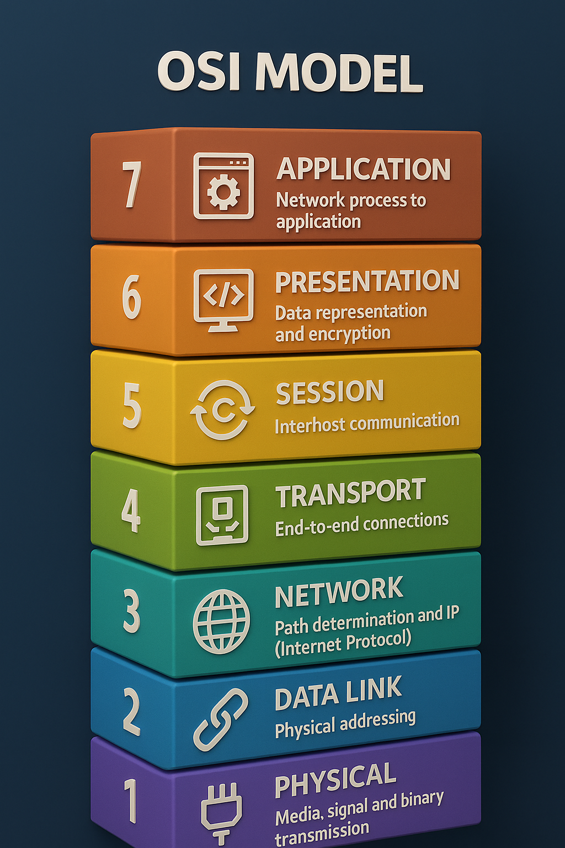  
  
11) What is an IPv4 address? What are the different classes of IPv4?    
Answer:-An IPv4 address is a unique number used to identify a device on a network, like a computer or phone, and it is written as four numbers separated by dots (for example, 192.168.1.1). It has five classes: Class A (for very large networks), Class B (for medium networks), and Class C (for small networks). Class D is used for sending data to many devices at once (multicasting), and Class E is reserved for research. Each class has a different range of numbers, and some ranges like 192.168.x.x are used for private networks (like home Wi-Fi).

12) What are the advantages of using VPN?  
Answer:- A VPN (Virtual Private Network) helps keep your internet connection safe and private by hiding your IP address and encrypting your data. It protects you when using public Wi-Fi, making it harder for hackers to steal your information. A VPN also lets you access websites or content that may be blocked in your country.

13)What are Types of VPN?  
Answer:-   
Access VPN: Connects individual users to a private network from remote locations.

Site-to-Site VPN: Connects entire office networks in different locations securely.

Intranet VPN: Connects different branches of the same company to share data safely.

Extranet VPN: Connects a company with its partners or clients securely over the internet.

14) what is node and link?   
Answer:-  
A node is any device or point in a network, like a computer, router, or printer.  
A link is the connection between two nodes that allows them to share data, like a cable or wireless signal.

15) what is network topology?  
Answer:- Network topology is the way computers, devices, and cables are arranged and connected in a network. It shows how data moves between devices, like in a line, circle, or star shape.  
  
16) what are different types of network topology?  
Answer:- Here are the different types of network topology :

1. **Bus Topology**: All devices are connected in a single line using one main cable.
2. **Star Topology**: All devices are connected to a central device like a switch or hub.
3. **Ring Topology**: Devices are connected in a circular loop, and data moves in one direction.
4. **Mesh Topology**: Every device is connected to every other device for strong communication.
5. **Tree Topology**: It has a central root and branches out like a tree, combining star and bus topologies.
6. **Hybrid Topology**: It mixes two or more types of topologies in one network.  
     
   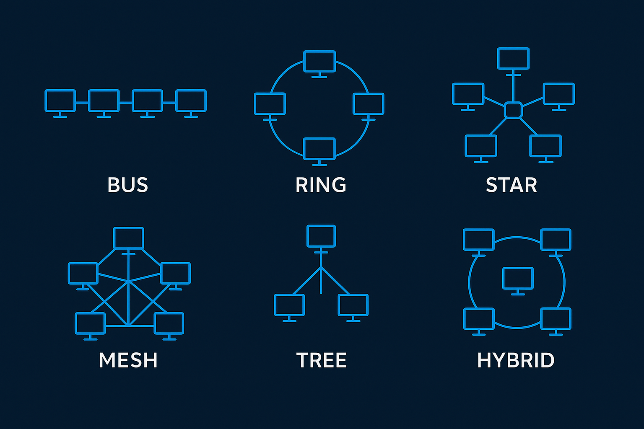

17) What is extended bus topolugy ? its Tree Toplogy.

Answer:- An Extended Bus Topology is a version of the regular Bus Topology, where multiple bus lines are connected together using extra cables or repeaters to make a larger network. It’s like having several bus lines linked end-to-end. Data travels along the bus, and each device checks if the data is meant for it. In contrast, Tree Topology is a combination of Bus Topology and Star Topology, where several star-shaped networks (with a central hub connecting devices) are connected to a central bus (like the trunk of a tree). This setup allows easy expansion, but if the main bus fails, the whole network can be affected. Both topologies are used to organize networks, but Tree Topology is more flexible and can handle more devices, while Extended Bus Topology is simpler but has limits as the network grows.

18) What is the use of a router and how is it different from a gateway?

Answer:- A router is a device that helps send data between different networks, like connecting your home network to the internet. It makes sure the data takes the best path to reach its destination. On the other hand, a gateway is a device that connects two different networks that may use different systems or protocols, allowing them to communicate with each other. While a router only moves data between networks, a gateway helps different types of networks talk to each other, even if they use different languages or technologies. So, a router manages the traffic, and a gateway bridges networks that are otherwise not compatible.  
  
  
  
  
  
19) Explain SMTP Protocol with diagram.

Answer:-

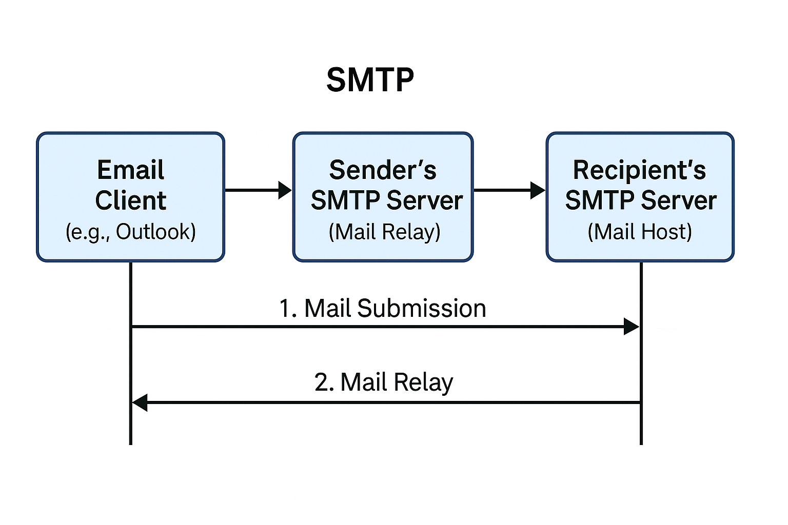

This image shows how an email is sent using the SMTP (Simple Mail Transfer Protocol). It starts with the *Email Client* (like Outlook or Gmail), where a person writes and sends an email. That email goes to the *Sender’s SMTP Server, which is the mail server of the person sending the message — this step is called **Mail Submission. Then, the sender’s server forwards the email to the **Recipient’s SMTP Server, which is the server of the person who will receive the email — this is called **Mail Relay. Finally, the **Recipient’s SMTP Server* stores the email so the receiver can open it later — this step is called *Delivery*. This entire process happens quickly and uses the SMTP protocol to move the email from sender to receiver.  
  
20) Differentiate between OSI and TCP/IP

Answer:- The OSI(Open Systems Interconnection) and TCP/IP(Transmission Control Protocol/Internet Protocol) models are both used to understand how computer networks work. The OSI model has 7 layers (like Application, Transport, Network, etc.) and was created by ISO (International Organization for Standardization) as a reference model, while the TCP/IP model has 4 layers and is the one actually used on the internet. OSI is more theoretical and separates each function clearly, while TCP/IP is more practical and based on real protocols like TCP and IP. OSI is protocol-independent, meaning it doesn’t depend on any one technology, but TCP/IP was developed around specific protocols. Overall, OSI is used more for learning and understanding, while TCP/IP is used in real-world communication.  
  
  
  
  
  
21)What is HLD and LLD in SDLC?  
Answer:-   
High‑Level Design (HLD): a big‑picture plan that lists all main parts of the software and how they connect.  
Low‑Level Design (LLD): a detailed guide for each part, showing the exact logic, data, and code needed to build it.  
  
22)What is HTTP and HTPPS ?  
Answer:-HTTP (HyperText Transfer Protocol) is the system used for transferring data between a web browser (like Chrome) and a website. It allows you to view websites, click links, and load web pages. However, HTTP is not secure, which means the data sent between you and the website can be seen by others.  
  
HTTPS (HyperText Transfer Protocol Secure) is the secure version of HTTP. It uses encryption (SSL/TLS) to protect the data sent between your browser and the website. This means your information like passwords, card details, or personal data is safe from hackers.

23) What is SRS?Explain with the diagram?   
Answer:-SRS (Software Requirements Specification) is a document that explains in detail what a software should do. It includes all the features, rules, and conditions the software must follow, such as how it should work, who will use it, and how fast or secure it should be. This document helps developers, testers, and clients stay on the same page before the software is built. In simple terms, SRS is like a clear plan or guide for creating the software without confusion.  
  
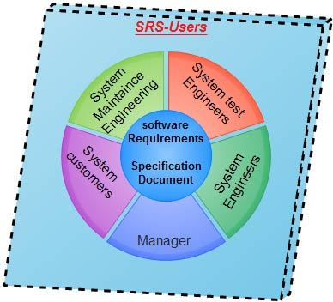

SDLC MCQ’s:-

1. **A feasibility study using the SDLC model is conducted to:**  
   a) Determine whether or not the project is technically possible  
   b) Determine whether the proposal is financially viable  
   c) Both a and b  
   d) None of the above  
   **Answer**: c) Both a and b
2. **A well-documented life cycle model aids in the detection of what during the development phase?**  
   a) Inconsistencies  
   b) Redundancies  
   c) Omission  
   d) All of the above  
   **Answer**: d) All of the above
3. **How many lines of code does the Build & Fix Model suit for programming exercises?**  
   a) 100-200  
   b) 300-400  
   c) 600-700  
   d) Above 800+  
   **Answer**: a) 100-200
4. **In which life cycle does regression testing play a significant role?**  
   a) Waterfall model  
   b) V model  
   c) Iterative model  
   d) All of the above  
   **Answer**: d) All of the above
5. **What determines if the project should go forward?**  
   a) Feasibility assessment  
   b) Opportunity identification  
   c) System evaluation  
   d) Program specification  
   **Answer**: a) Feasibility assessment
6. **What is the most significant disadvantage of employing the RAD Model?**  
   a) Developers/designers that are highly specialized and skilled are required.  
   b) Component reusability is improved.  
   c) Encourages client/customer input.  
   d) Increases component reusability.  
   **Answer**: a) Developers/designers that are highly specialized and skilled are required.
7. **Which of the following developmental models is incremental?**  
   a) Prototyping, V model, Agile  
   b) Prototyping, RAD, Agile, RUP  
   c) Prototyping, V model, RAD, Agile, RUP  
   d) All of the above  
   **Answer**: b) Prototyping, RAD, Agile, RUP
8. **Which of the following is an Agile development characteristic?**  
   a) Shared code ownership  
   b) Test-Driven Development  
   c) Implement the simplest solution to meet today's problem  
   d) Continual feedback from customer  
   e) All of the above  
   **Answer**: e) All of the above
9. **Which of the following steps in the SDLC framework are valid?**  
   a) Requirement Gathering  
   b) Software Design  
   c) System Analysis  
   d) All of the above  
   **Answer**: d) All of the above
10. **Who is in charge of system development, staffing, budgeting, and reporting, as well as ensuring that deadlines are met?**  
    a) Project managers  
    b) Network engineers  
    c) Graphic designers  
    d) Systems analysts  
    **Answer**: a) Project managers